# XYZ Ads Airing Report Analysis

### **Final Project-3**

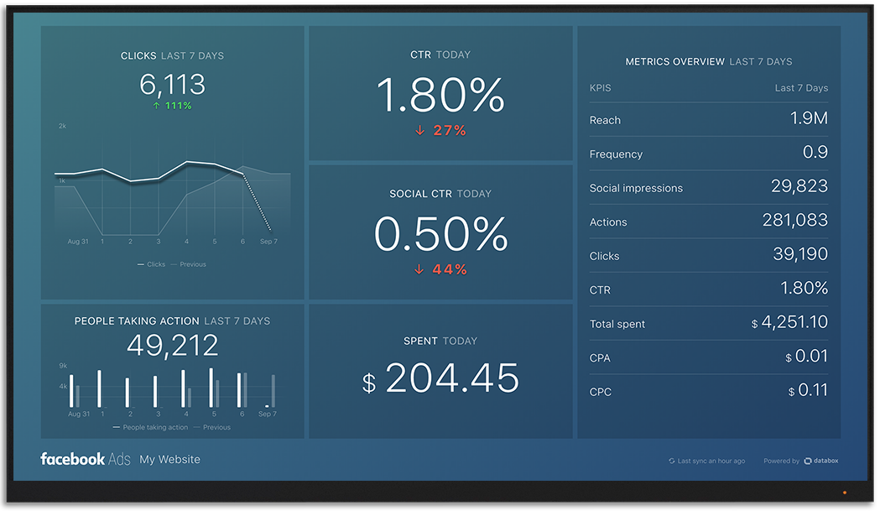

**By- ROHIT BAHUGUNA**

## Project Description:

Advertising is a way of marketing your business in order to increase sales or make your audience aware of your products or services. Until a customer deals with you directly and actually buys your products or services, your advertising may help to form their first impressions of your business. Target audience for businesses could be local, regional, national or international or a mixture. So they use different ways for advertisement. Some of the types of advertisement are: Internet/online directories, Trade and technical press, Radio, Cinema, Outdoor advertising, National papers, magazines and TV. Advertising business is very competitive as a lot of players bid a lot of money in a single segment of business to target the same audience. Here come the analytical skills of the company to target those audiences from those types of media platforms where they convert them to their customers at a low cost.

The dataset contains different TV Airing Brands, their product, their category of some brands from the Automobile industry. Dataset includes the network through which Ads are airing, types of network like Cable/ Broadcast and the show name also on which Ads got aired. We can also see the data of Dayparts, Time zone and the time & date at which Ads got aired. It also includes other data like Pod Position (the lesser the valuable), duration for which Ads aired on screen, Equivalent sales &, total amount spent on the Ads aired.

## Approach:

In this analysis, the first step is to go through the data set, clearly understand the variables, contained in the dataset. We will observe how given variable are related with case study and given task. Their inter-relation between columns, null values in the given task. The analysis can be done using statistical formulas and can also be done using Tech tools like MS-excel and MS-word.

## Tech-stack:

* MS-Excel- it is used for data cleaning, visualization and analysis of the provided data.
* MS-word- It helps in creating and editing document, and also helpful in making document interactive with tools.

## Analysis outcome:

1. **What is Pod Position? Does the Pod position number affect the amount spent on Ads for a specific period of time by a company? (Explain in Details with examples from the dataset provided)**

**Solution:** An ad pod is a group of ads that are sequenced together to be played back-to-back within a single ad break/placement, similar to ad breaks in traditional linear TV. Ad pods give publishers the opportunity to maximize revenue from each ad break and give advertisers more control over ad positioning.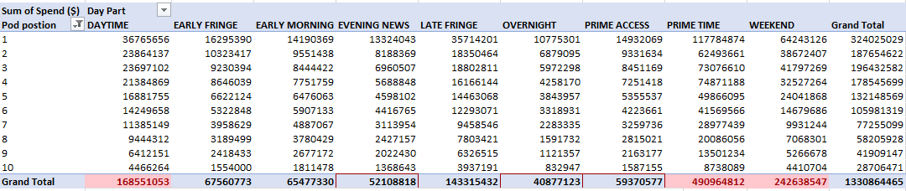

Figure-1

EQ units is the measure to tell how much product is into the audience as compare to the product of same type of product.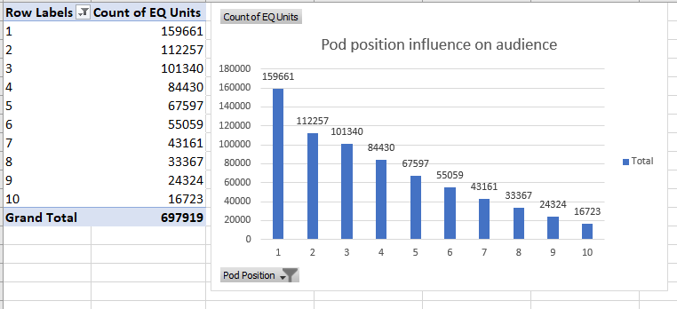Figure -2

From both the above graph, we can say that pod position influences the reach of that product in the audience and to get low pod position you have to spend so much money.

1. **What is the share of various brands in TV airings and how has it changed from Q1 to Q4 in 2021?**

**Solution-** In the below shown graph:

* 4 groups (i.e. Q1, Q2, Q3, Q4) are group of 3 months.
* Maruti Suzuki has highest share among all the quarters.
* The graph shows that share decreases from Q1 to Q4.

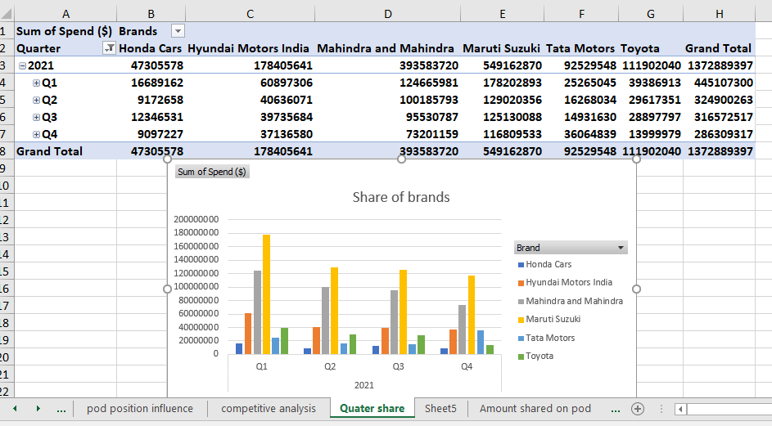

Figure-3

1. **Conduct a competitive analysis for the brands and define advertisement strategy of different brands and how it differs across the brands.**

**Solution:**

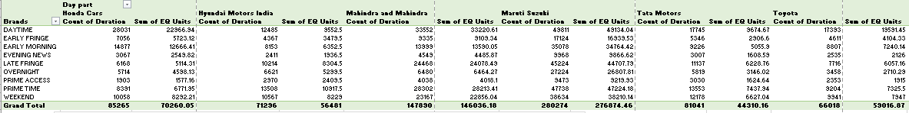Figure-4

Figure-5

* I have considered columns, Dayparts, Duration, Brand, EQ Units, Brand Months as Quarters.
* Maruti Suzuki advertise their products in all their day parts, with high duration and high EQ.
* The ads of maruti Suzuki are more people engaging in all the day parts and with high play duration which make them profit more.

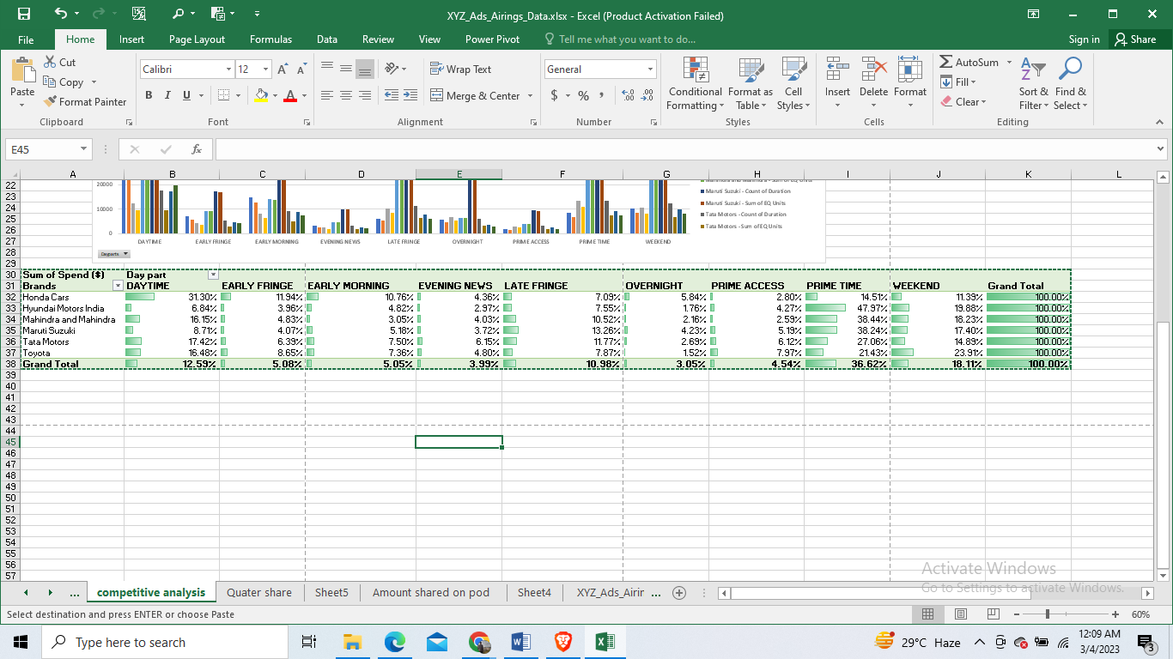

Figure-6

From the above table, we can say that:

* At prime time, all brands spend most of the money.
* Honda Car spend most at the daytime, early fringe and early morning ads.
* At weekend, Toyota car spends the most.
* On late fringe and overnight ads, Maruti Suzuki spends the most.

1. **Mahindra and Mahindra wants to run a digital ad campaign to complement its existing TV ads in Q1 of 2022. Based on the data from 2021, suggest a media plan to the CMO of Mahindra and Mahindra. Which audience should they target? *Assume XYZ Ads has the ad viewership data and TV viewership for the people in India.**

**Solution:** We will look at the data of Mahindra and Mahindra in the dataset in order to get some fruitful insights.

**Table1:**

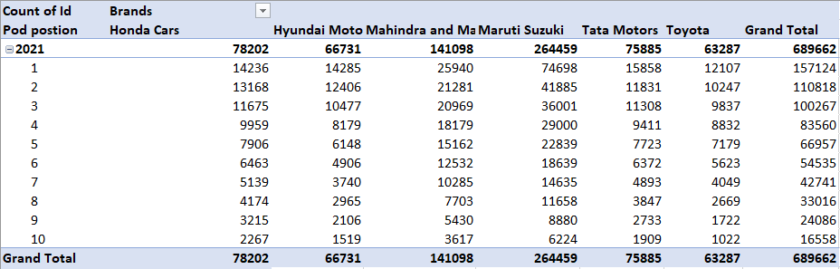

Figure-7

**Table2:**

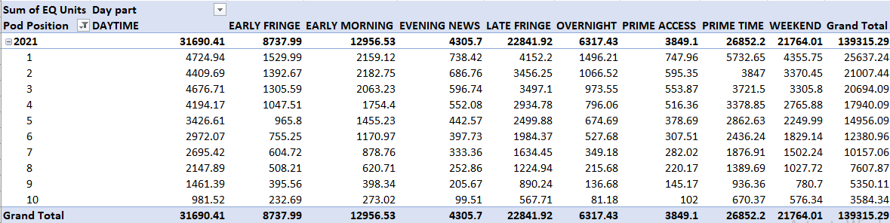

Figure-8

**Table3:**

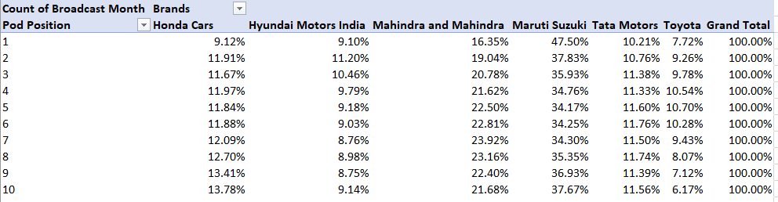

Figure-9

* Here, we have used the pivot table feature of MS word in INSERT tab.
* We have considered ID, BRAND, POD POSITION and BROADCAST_YEAR to form table1.
* We have considered BRAND, POD POSITION and EQ_UNITs, BROADCAST_YEAR and DAY PART to form table2.
* We have considered BRAND, POD POSITION and BROADCAST_MONTHS to form table3.

From these tables, we can say that:

* From table1, we can say that, the company must show more number of ads at pod position 1, 2 and 3 because lower position has more impact on people.
* From Table 2, Ads during daytime, prime time and weekends have more reach among people due to high EQ sum and at evening, prime access and overnight have low EQ sum. So, company must increase frequency of ads in that period of low EQ sum.
* From table3, Percentage of broadcast in a month specially at low pod positions is very low. So company must make strategies in order to draw attention of more number of

peoples.

Target Audience: Mahindra and Mahindra should target the audience of prime access, Evening and Overnight audience because at this time audience reach is less due to least EQ sum.

**ADDITIONAL:**

**How much amount is spending on advertisement on different products of company?**

**Solution:**

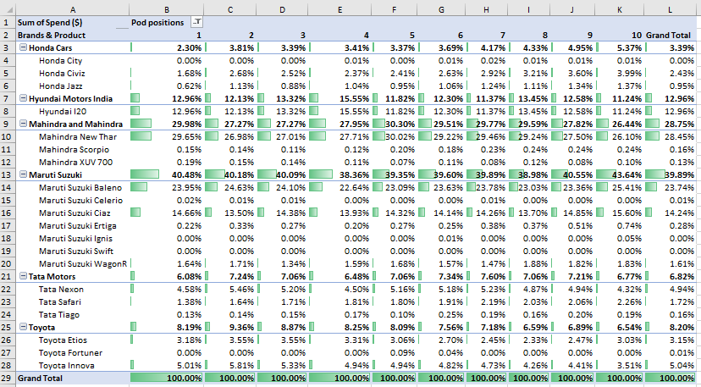

**Figure-10**

* In the above pivot table, we can see, almost no money spends for Honda City, Maruti Suzuki Celerio, Maruti Suzuki Ignis, Maruti Suzuki Swift and Toyota Fortuner.
* The money spends the most on the advertisement of Mahindra New Thar (28.45%) and Maruti Suzuki Baleno (23.74%).
* The total share of money spends by Mahindra and Mahindra is 28.75%.
* The total share of money spends by maruti Suzuki is 39.89%.
* The total share of money spends by Hyundai motor India is 12.96%.
* For pod position1, Maruti Suzuki spend highest money (40.48%).

## Insights:

* The share value is high in Quarter 1 and low in Quarter 4 of 2021.
* Maruti Suzuki telecasts the advertisements in almost all day parts.
* Mahindra and Mahindra should telecast their advertisements in almost all parts, so that it can be a good growth start for the year 2023.
* Maruti Suzuki has spent equal amount in all the quarters.
* The brand’s money spent for the advertisement is the least for the last quarter pod position and the highest for the first quarter pod position.
* The money spent by Mahindra and Mahindra is the most for the pod position ads.
* The money spent by Honda Cars is the least for the pod position ads.
* The money spent by the Maruti Suzuki is the most consistent for all the Quarters of the year.
* People watch the most in the prime time and on weekend.
* The Ads are shown the least in the prime access and evening news parts of the day.

## Result:

* I learned how a data analyst can help the company to learn where to spend the money to get the maximum profit.
* I learned about the pod position. I got to know how the ordering of ads are related to the money spent by the company.
* I implemented the understanding of competitive analysis and how it can be done to get the valuable insights.
* I learned the analytical skills of how a company can convert the audience to their customers at a low cost.

**This is my spreadsheet reference link:**

## Drive link: **https://drive.google.com/drive/folders/19qGpG7l16-abZsUPns0Kj3tORDyxYOij?usp=share_link**